**The Muirrel**

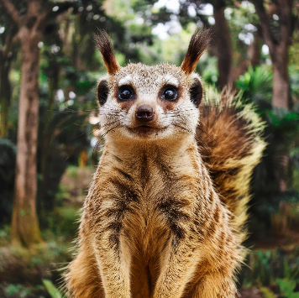

Beside the big, blue lake

Is the wonderful Muirrel baking pancakes

He is furry and cute

And collects lots of loot.

If he goes zap

He will turn into a bat

When he is a bat

He really likes cats!

One day when the Muirrel woke up

He noticed outside there was a duck

The duck went quack then turned his back

Then realized he was an acrobat!

# By Georgios Vasileiou